Wrapping a Primitive Type in a Wrapper Object

- In the Java language, the eight primitive types --- boolean, byte, char, short, int, long, float, double --- are not objects.
- However, in certain situations, objects are required. For example, collection classes such as Map and Set only work with objects.
- This issue is addressed by wrapping a primitive type in a wrapper object.
- There is a wrapper object for each primitive type.

This example demonstrates how to wrap the value of a primitive type in a wrapper object and then subsequently retrieve the value of the primitive type.

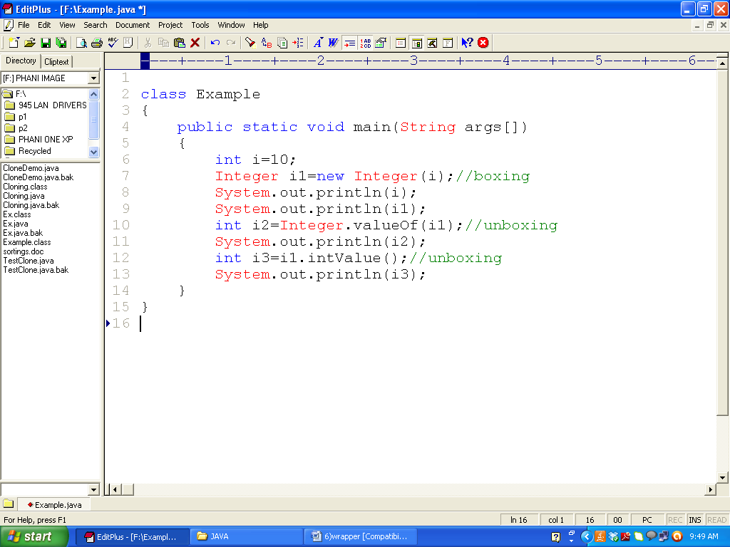
Auto boxing and unboxing using wrapper class
- Getting the derived object from a primitive data type is called the boxing.
- Getting the primitive data type from the derived object called unboxing.
- Boxing and unboxing is happening automatically using wrapper classes using java 5 or newer version.
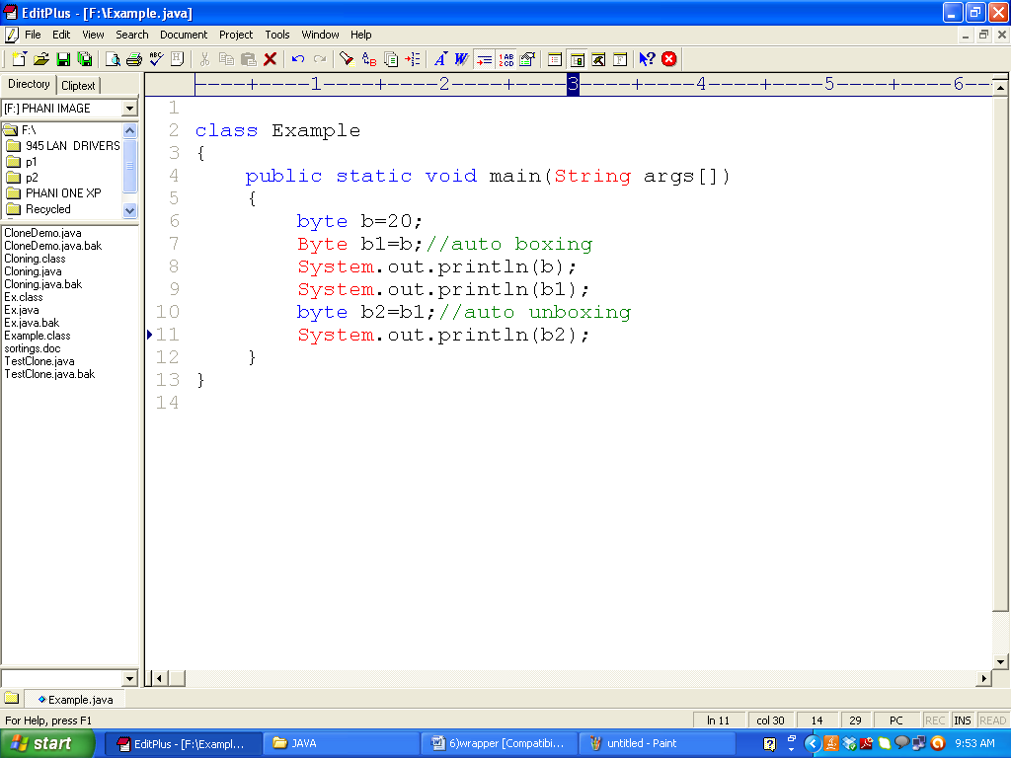

class Example
{
public static void main(String[] args)
{
int i=10;
byte b=20;
Integer i1=new Integer(i);//boxing
int i2=Integer.valueOf(i1);//unboxing
int i3=i1.intValue();//unboxing
System.out.println(i1);
System.out.println(i2);
System.out.println(i3);

Byte b1=b;//auto boxing
byte b2=b1;//auto unboxing

}
}

public class Main {
public static void main(String[] args) {
System.out.println(Short.MIN_VALUE);
System.out.println(Short.MAX_VALUE);
}
}

public class Main
{
public static void main(String[] args)
{
System.out.println((int)Character.MIN_VALUE);
System.out.println((int)Character.MAX_VALUE);
}
}

public class Main
{
static char ch=0;
static
{
for(int i=0;i<65535;i++)
{
System.out.print(i+"="+ch+"\t");
ch++;
}
}
}

//String to Byte :

public class Main
{
public static void main(String[] args)
{
String s = "65"; //auto boxing
byte b = Byte.valueOf(s);//unboxing
System.out.println(b);

String s1 = "650"; //auto boxing
byte b1 = Byte.valueOf(s1);//unboxing
System.out.println(b1);
}
}

public class Main {
public static void main(String[] args) {
System.out.println(Integer.MIN_VALUE);
System.out.println(Integer.MAX_VALUE);
}
}

public class Main
{

public static void main(String args[])
{
int i = Integer.parseInt("3");
int j = Integer.parseInt("5");
int sum = i + j;
System.out.print("Sum is " + sum);
}
}

//byte to string conversion:

public class Main
{
public static void main(String[] args)
{
byte b=10;//primitive byte
Byte b1 = new Byte(b);//boxing
String str = b1.toString(); //converting byte obj to str obj
System.out.println(str);//prints string
}
}

class Main
{
public static void main(String agrs[])
{
int a=5,b=2;
float c;
c = (float)a/b;
System.out.println(c);
}
}

class Main
{
public static void main(String agrs[])
{
//Character to Integer
char c='9';//store ascii value of 9(57)
System.out.println(c);
int i=(int)c; //explicit type casting
System.out.println(i);

int k='0';//implicit type casting
System.out.println(k);
//String to Character
String s="65";//auto boxing
byte b=(byte)s;
System.out.println(b);
}
}

notes:
1)we can convert one primitive into another primitive type using type casting technique.
2) if we want to convert object type into primitive type either we can use unboxing or auto unboxing(same type).
3) we can convert primitive type obj type using boxing or auto boxing(same type)
4) we cannot convert obj to primitive type just by using type casting technique.

class B
{
public static void main(String args[])
{
String s="27"; //CE:incovertable types
int i=(int)s;
System.out.println(i);

}
}
CONVERTING INTEGER TO STRING or STRING TO INTEGER USING WRAPPER CLASS METHODS:

class Main
{
public static void main(String agrs[])
{
int a=97;
String s=Integer.toString(a);
System.out.println(s);

String s="97";

byte b=10;
Byte b1=new Byte(b);
String str=b1.toString();
System.out.println(str);

//(or)

//String s=" "+a;
//System.out.println(s);

}
}

Public String toString() → is a Object class method override in Wrapper classes used to convert
Any Wrapper class object into String type

Public static toString(primitive type) → is a static method defined separately in wrapper classes
Used to convert the primitive type values into String type

class Student
{
int a;
static int b; // initialized to zero only when class is loaded
Student()
{
b++;
}
public void showData()
{
System.out.println("Value of a = "+a);
System.out.println("Value of b = "+b);
}
}
class Demo
{
public static void main(String args[])
{
Student s1 = new Student();
s1.showData();
Student s2 = new Student();
s2.showData();
Student.b++;
s1.a=10;
s1.showData();
s2.showData();
}
}

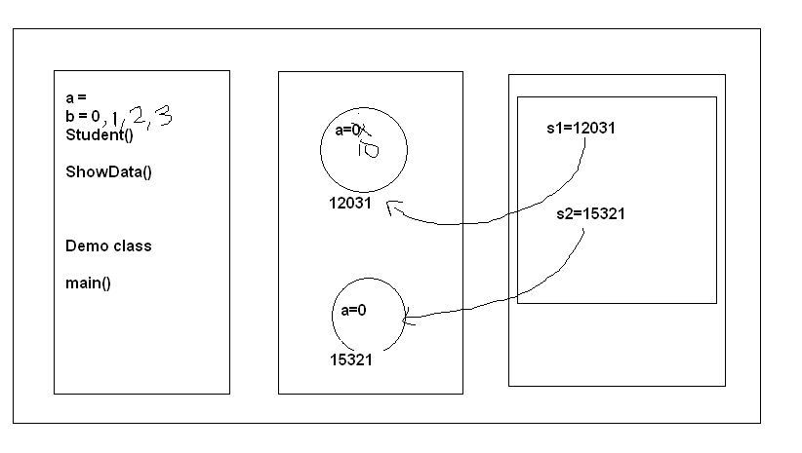

10+20==30
naresh+tech=nareshtech

str+int=string
int +int=int
str+str=str

class Example
{
public static void main(String args[])
{
//Character to Integer
char c='9';
System.out.println(c);
int i=(int)c; //explicit type casting
System.out.println(i);
int ch='8'; //implicit type casting
System.out.println(ch);

int i1=10;
Integer i2=new Integer(i1); //boxing;

int i3=i2; //auto boxing

byte b=10;//primitive byte
Byte bObj = new Byte(b);//boxing
String str = bObj.toString(); //converting byte obj to str obj
System.out.println(str);

//String to Character
String s="welcome";
// char c1=(char)s;

String s="27"; //CE:incovertable types
int i=(int)s;
System.out.println(i);

String s = "65"; //auto boxing
byte b = Byte.valueOf(s);//unboxing

}
}

//primitive --primtive(explicit, implicit)
//primitive--object(boxing, auto boxing)
//object-- primitive(auto unboxing and unboxing)
// object ---object (byte obj to string object)
//object ---primitive (we cannot use casting)

